Practical-6

Name:-Vishwajit kate

Reg. No:-2020BIT011

# write a C/C++ program to implement Decrease and conquer algorithm

# 1) Insertion sort

# 2) DFS

# 3) BFS

# 1) Insertion Sort

# Code:-

// Reg No:2020BIT011

#include <stdio.h>

void printArray(int array[], int size) {

for (int i = 0; i < size; i++) {

printf("%d ", array[i]);

}

printf("\n");

}

void insertionSort(int array[], int size) {

for (int step = 1; step < size; step++) {

int key = array[step];

int j = step - 1;

while (key < array[j] && j >= 0) {

array[j + 1] = array[j];

--j;

}

array[j + 1] = key;

}

}

int main() {

int data[] = {9, 5, 1, 4, 3};

int size = sizeof(data) / sizeof(data[0]);

insertionSort(data, size);

printf("Sorted array in ascending order:\n");

printArray(data, size);

}

**Output:**

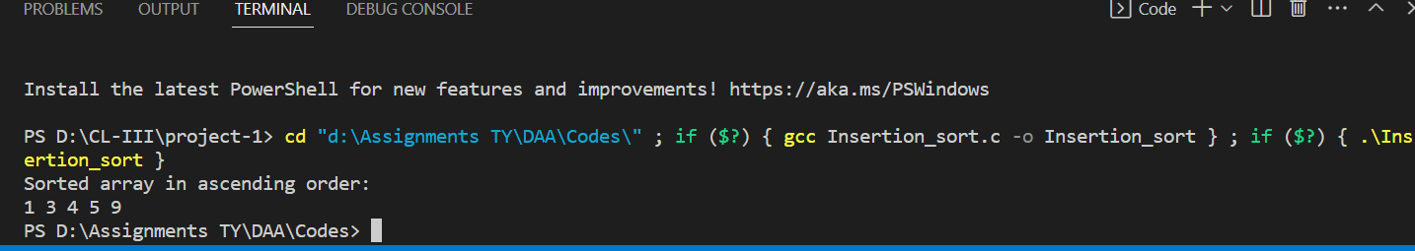

# 2) DFS

# Code:-

# // Reg No:2020BIT011

#include <stdio.h>

#include <stdlib.h>

struct node {

int vertex;

struct node* next;

};

struct node* createNode(int v);

struct Graph {

int numVertices;

int* visited;

struct node** adjLists;

};

void DFS(struct Graph* graph, int vertex) {

struct node* adjList = graph->adjLists[vertex];

struct node* temp = adjList;

graph->visited[vertex] = 1;

printf("Visited %d \n", vertex);

while (temp != NULL) {

int connectedVertex = temp->vertex;

if (graph->visited[connectedVertex] == 0) {

DFS(graph, connectedVertex);

}

temp = temp->next;

}

}

struct node* createNode(int v) {

struct node* newNode = malloc(sizeof(struct node));

newNode->vertex = v;

newNode->next = NULL;

return newNode;

}

struct Graph* createGraph(int vertices) {

struct Graph* graph = malloc(sizeof(struct Graph));

graph->numVertices = vertices;

graph->adjLists = malloc(vertices * sizeof(struct node*));

graph->visited = malloc(vertices * sizeof(int));

int i;

for (i = 0; i < vertices; i++) {

graph->adjLists[i] = NULL;

graph->visited[i] = 0;

}

return graph;

}

void addEdge(struct Graph* graph, int src, int dest) {

struct node* newNode = createNode(dest);

newNode->next = graph->adjLists[src];

graph->adjLists[src] = newNode;

newNode = createNode(src);

newNode->next = graph->adjLists[dest];

graph->adjLists[dest] = newNode;

}

void printGraph(struct Graph* graph) {

int v;

for (v = 0; v < graph->numVertices; v++) {

struct node* temp = graph->adjLists[v];

printf("\n Adjacency list of vertex %d\n ", v);

while (temp) {

printf("%d -> ", temp->vertex);

temp = temp->next;

}

printf("\n");

}

}

int main() {

struct Graph* graph = createGraph(4);

addEdge(graph, 0, 1);

addEdge(graph, 0, 2);

addEdge(graph, 1, 2);

addEdge(graph, 2, 3);

printGraph(graph);

DFS(graph, 2);

return 0;

}**Output:**

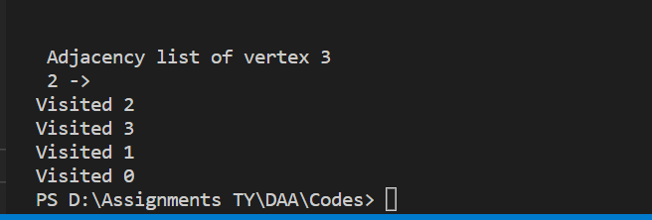

# 3) BFS

# Code:-

// Reg No:2020BIT011

#include <stdio.h>

#include <stdlib.h>

#define SIZE 40

struct queue {

int items[SIZE];

int front;

int rear;

};

struct queue* createQueue();

void enqueue(struct queue* q, int);

int dequeue(struct queue* q);

void display(struct queue* q);

int isEmpty(struct queue* q);

void printQueue(struct queue* q);

struct node {

int vertex;

struct node* next;

};

struct node* createNode(int);

struct Graph {

int numVertices;

struct node** adjLists;

int* visited;

};

void bfs(struct Graph* graph, int startVertex) {

struct queue* q = createQueue();

graph->visited[startVertex] = 1;

enqueue(q, startVertex);

while (!isEmpty(q)) {

printQueue(q);

int currentVertex = dequeue(q);

printf("Visited %d\n", currentVertex);

struct node* temp = graph->adjLists[currentVertex];

while (temp) {

int adjVertex = temp->vertex;

if (graph->visited[adjVertex] == 0) {

graph->visited[adjVertex] = 1;

enqueue(q, adjVertex);

}

temp = temp->next;

}

}

}

struct node* createNode(int v) {

struct node* newNode = malloc(sizeof(struct node));

newNode->vertex = v;

newNode->next = NULL;

return newNode;

}

struct Graph* createGraph(int vertices) {

struct Graph* graph = malloc(sizeof(struct Graph));

graph->numVertices = vertices;

graph->adjLists = malloc(vertices * sizeof(struct node*));

graph->visited = malloc(vertices * sizeof(int));

int i;

for (i = 0; i < vertices; i++) {

graph->adjLists[i] = NULL;

graph->visited[i] = 0;

}

return graph;

}

void addEdge(struct Graph* graph, int src, int dest) {

struct node* newNode = createNode(dest);

newNode->next = graph->adjLists[src];

graph->adjLists[src] = newNode;

newNode = createNode(src);

newNode->next = graph->adjLists[dest];

graph->adjLists[dest] = newNode;

}

struct queue* createQueue() {

struct queue* q = malloc(sizeof(struct queue));

q->front = -1;

q->rear = -1;

return q;

}

int isEmpty(struct queue* q) {

if (q->rear == -1)

return 1;

else

return 0;

}

void enqueue(struct queue* q, int value) {

if (q->rear == SIZE - 1)

printf("\nQueue is Full!!");

else {

if (q->front == -1)

q->front = 0;

q->rear++;

q->items[q->rear] = value;

}

}

int dequeue(struct queue* q) {

int item;

if (isEmpty(q)) {

printf("Queue is empty");

item = -1;

} else {

item = q->items[q->front];

q->front++;

if (q->front > q->rear) {

printf("Resetting queue ");

q->front = q->rear = -1;

}

}

return item;

}

void printQueue(struct queue* q) {

int i = q->front;

if (isEmpty(q)) {

printf("Queue is empty");

} else {

printf("\nQueue contains \n");

for (i = q->front; i < q->rear + 1; i++) {

printf("%d ", q->items[i]);

}

}

}

int main() {

struct Graph* graph = createGraph(6);

addEdge(graph, 0, 1);

addEdge(graph, 0, 2);

addEdge(graph, 1, 2);

addEdge(graph, 1, 4);

addEdge(graph, 1, 3);

addEdge(graph, 2, 4);

addEdge(graph, 3, 4);

bfs(graph, 0);

return 0;

}

**Output:-**

